AMANA TRUST DIAGNOSTICS
No 15, Tudun Wada C, Nasarawa LGA, Kano State.
Phone; +2348164093504, +2348033390574
Email; amanatrust2022@gmail.com

1/11/2026 2:10 PM
NAME: BILKISU IDRIS | Age: AD | Sex: F | Ref No:
Clinical Details: USG Pelvic |  |  |  | US:

REAL TIME PELVIC ULTRASONOGRAPHY EXAM: REVEALED:

URINARY BLADDER: Distended with urine with normal mucosal thickness. No gross masses or stone seen.

UTERUS: Anteverted and empty. Normal in size and contour. Myometrial and central endometrial echoes are preserved.

ADNEXAE: Right Shows cystic lesion with no internal nodules, septae or debris with good posterior acoustic enhancement. It measures about 41 mm X 41mm. Left adnexia appeared preserved.

CUL-DE-SAC: No sonographic abnormalities detected in anterior and posterior cul-de-sac.

CONCLUSION: The USS Features are suggestive of Right Simple Ovarian Cyst.

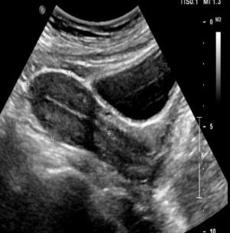

Rad R.A. ATIKU
Ultrasound specialist.

